Walking Directions – Leeds City Train Station to the Hilton Leeds City Hotel

Hilton Leeds City Hotel, Neville Street, Leeds LS1 4BX

- From the ticket barriers in Leeds Station, walk straight ahead and through the glass exit doors in front of you.
- Once outside turn left.
- At the crossing, cross the small road (taxi exit from station) and turn right on to Bishopgate Street.
- Walk down the hill, past Shabab Express Restaurant and under the railway bridge (Neville Street).
- The Hilton Hotel is on your right hand side after the railway tunnel.

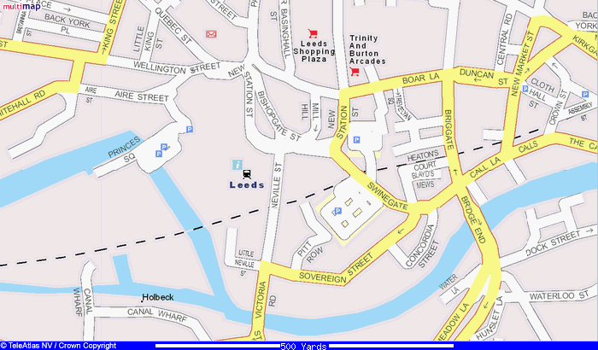
Hilton Leeds City Hotel


